1
Local Controller__________
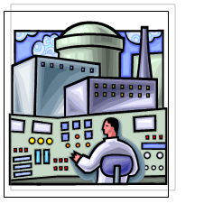 Chapter 1: Industrial Control
Chapter 2: Control Algorithm
Chapter 3: Microcontroller and Data Acquisition
Chapter 4: Controller Software
The term Local Controller in our project refers to the module which performs both data acquisition and control algorithms. It is considered as the core of the project since it performs the main task of sampling a process and controlling its output values.
In our project, the local controller was implemented as C-code software running on a Motorola HCS12 microcontroller. This microcontroller has accompanied the required hardware to perform analog and digital reading and writing, as well as timer interrupts to perform the actions at a fixed sampling rate.
We would like to note here that the local controller and Ethernet controller were actually implemented on the same microcontroller rather than using two separate hardware modules. This saved time and complexity in communicating between two separate hardware modules.

